Chesapeake Biological Laboratory’s Report of Monthly Cove Point Marsh Restoration Monitoring

Erin Reilly

August 16, 2019

## Activity Summary

#### July

* Salinity Surveys
* Download Weir Hobo Data

#### August (expected)

* Salinity Surveys
* Maintain Hobo sensors and download Hobo data
* Percent Cover Surveys
* PEET Plot Surveys
* Phragmites Biomass Collection
* Invasive Species Survey

## Items of Note/Concern:

* Water levels at the pond have been low and it has been difficult to access some of the areas. There are many more of the transient islands this year when compared to last year, likely the result of less rainfall and shallower depths.

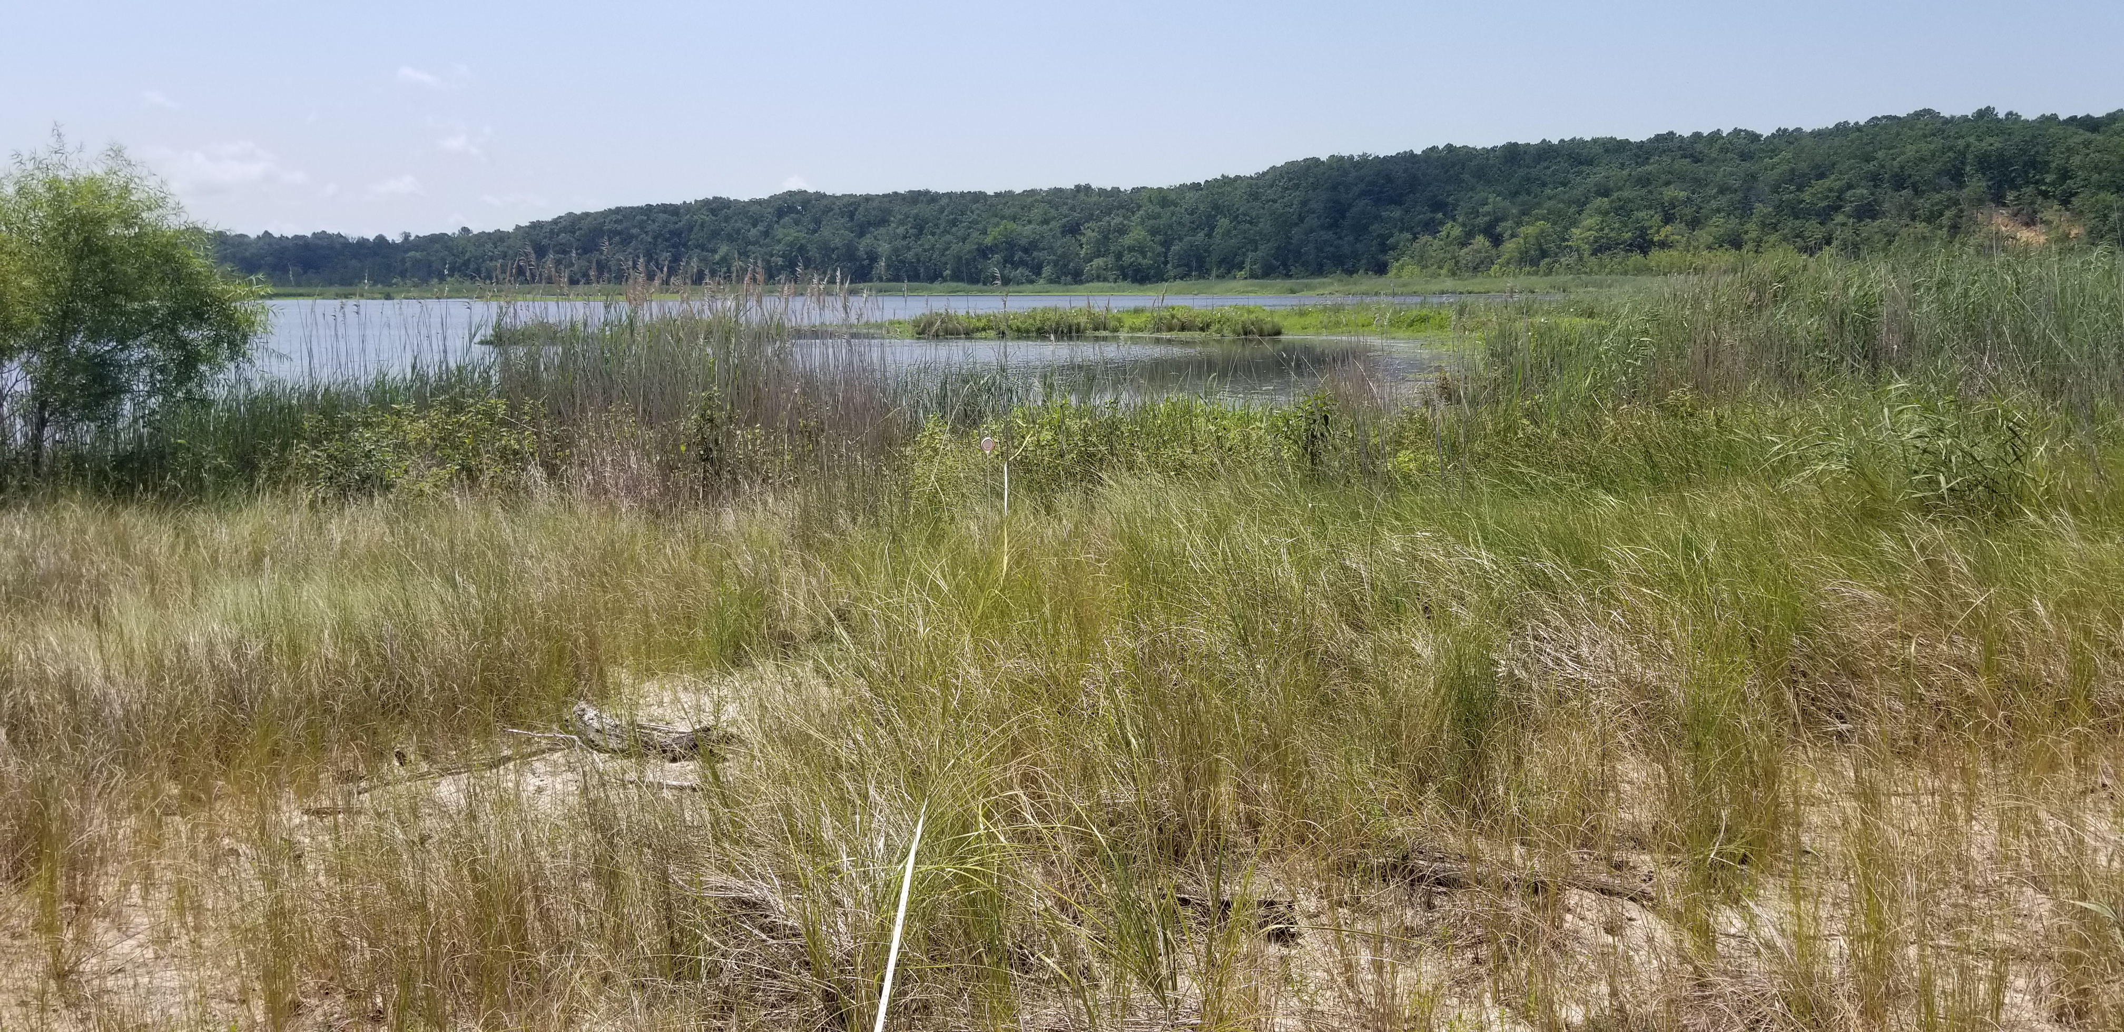

The Pond in July

## Plots

Below are the plots for the Hobos for the month of July.

### Water Level

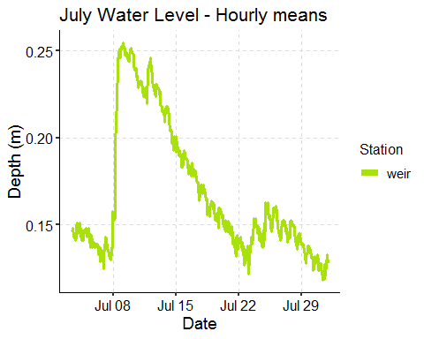

### Salinity

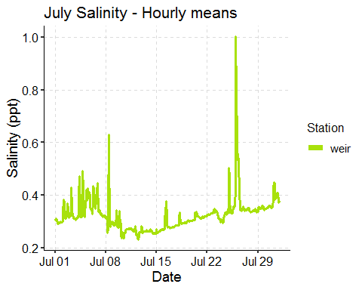

### Dominion Distribution List

1. Paul Dickson, Dominion ([paul.e.dickson@dom.com](mailto:paul.e.dickson@dom.com))
2. Mike Gardner, Dominion ([Michael.e.gardner@dom.com](mailto:Michael.e.gardner@dom.com))
3. Jasmine L Morris ([Jasmine.L.Morris@dom.com](mailto:Jasmine.L.Morris@dom.com))
4. Dominion Biology Group Contact, Matt Overton ([matt.overton@dom.com](mailto:matt.overton@dom.com))